

**“ Welfare Funding Project”**

**SUBMITTED BY: -**

Ashish Sharma(201500166)

**SUBMITTED TO: -**

**ABHISHEKH TIWARI SIR**

(Assistant Professor, GLA University)

**Declaration**

I hereby declare that the project work entitled “**WELFARE FUNDING PROJECT”** submitted to the GLA University Mathura, is a record of an original work done by me under the guidance of ABHISHEKH TIWARI , Assistant Professor, Computer Science, GLA and this project work is submitted in the partial fulfilment of the requirements for the award of the degree B.Tech in Computer Science & Engineering. The results embodied in these have not been submitted to any other University or Institute for the award of any degree or diploma.

Project Creator

ASHISH SHARMA(201500166)

Course: B.Tech (Computer Science and Engineering)

Year: 3rd

Semester: 5th

Supervised By

MR ABHISHEKH TIWAR SIR

GLA University, Department of Computer Engineering & Application

**Certificate**



**Department of computer Engineering and Applications**



**GLA University, Mathura**



**17**



**km. Stone NH#2, Mathura**



**-**



**Delhi Road, P.O.**



**–**



**Chaumuhan,**



**Mathura**



**–**



**281406**



This is to certify that the above statements made by the candidates are correct to the best of my/our knowledge and belief.

_______________________ Supervisor

ABHISHEKH TIWARI SIR

Assistant Professor

Project Mentor Program Coordinator (ABHISHEKH TIWARI) (Mr. Shashi Shekhar)

**Introduction**

**About the Project: -**

**Crowdfunding platforms are websites that enable interaction between fundraisers and the crowd. Financial pledges can be made and collected through the crowdfunding platform.**

**Fundraisers are usually charged a fee by crowdfunding platforms if the fundraising campaign has been successful. In return, crowdfunding platforms are expected to provide a secure and easy to use service.**

**Many platforms operate an all-or-nothing funding model. This means that if you reach your target you get the money and if you don’t, everybody gets their money back – no hard feelings and no financial loss.**

**There are a number of crowdfunding types which are explained below. This guide provides unbiased advice to help you understand the three most common types of crowdfunding used by profit-making SMEs and startups: peer-to-peer, equity and rewards crowdfunding.**

**Primary Reason to choose This Project: -**

I had choosed this project because I have upper hand on solidite as I had learned block chain and this contract is useful for people to be saved by companies or organisation who ask for fund for good reasons but take their money and ran away.

**The Main Objective of the project: -**

The main objective of this project’s is to create smart design contract which is to build trust between and donators and funds or organisation that their money is in safe hand and without permisiion of donators and majority votes organisation can’t access or take their money .

**Scope of the project: -**

* Usally for organisations and fund raising groups
* Easy calculation and maintainence of money raised
* Time efficeient and reliable trust worthy betn both donator and funds taker

**Acknowledgement**

It gives me a great sense of pleasure to present the End Term Report of the B.Tech mini project undertaken during B.Tech III Year. This project is going to be an acknowledgement to the inspiration, drive and technical assistance will be contributed to it by many individuals. I owe special debt of gratitude to ABHISHEKH SIR , Assistant Professor , for providing me with an encouraging platform to develop this project, which thus helped me in shaping my abilities towards a constructive goal and for his constant support and guidance to my work. His sincerity, thoroughness and perseverance has been a constant source of inspiration for me. We believe that he will shower me with all his extensively experienced ideas and insightful comments at different stages of the project & also taught me about the latest industry-oriented technologies. We also do not like miss the opportunity to acknowledge the contribution of all faculty members of the department for their kind guidance and co-operation.

Ashish Sharma(201500166)

\

**Working**

**Working Methodology of the project: -.**

* The business owner calls the contract to launch a campaign using several justifications, including the number of tokens that must be raised for the campaign, its start timestamp, and its end timestamp.
* As long as the campaign has not already begun, the business owner may cancel it at any time.
* By using the "pledge" function and entering the "id" of the campaign along with the number of tokens to be pledged, users can donate their tokens to a particular campaign.
* As long as the campaign is still active, they can also withdraw their previously pledged tokens.
* After the campaign is over, one of the two possible results is -

A campaign is considered successful when it raises the required number of tokens and meets the business owner's minimum requirements. In this scenario, the business owner can call the "claim" function to withdraw all the tokens.

If not enough tokens are pledged, which is the other scenario where a campaign fails, pledgers can withdraw their tokens from the contract by using the "withdraw" function.

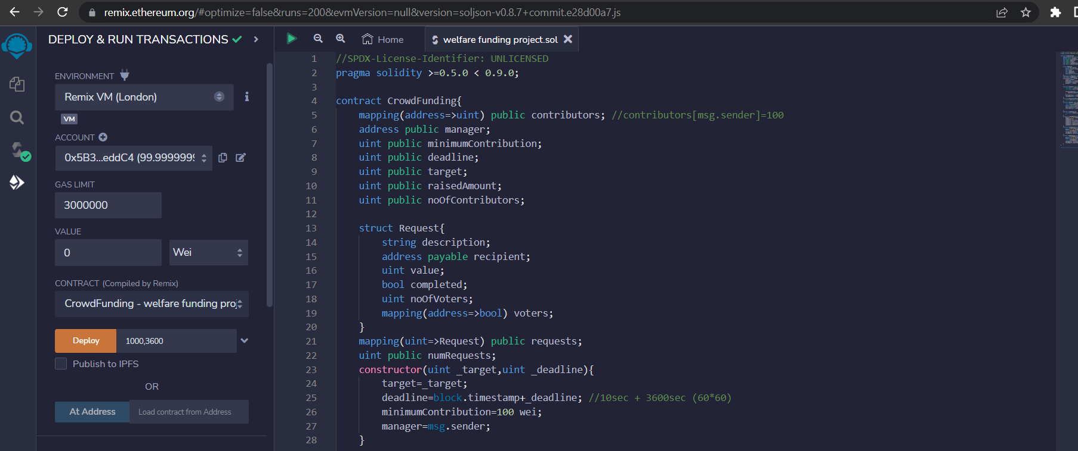

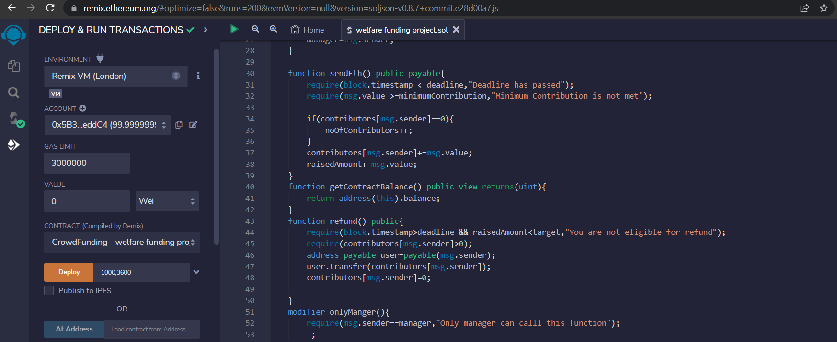

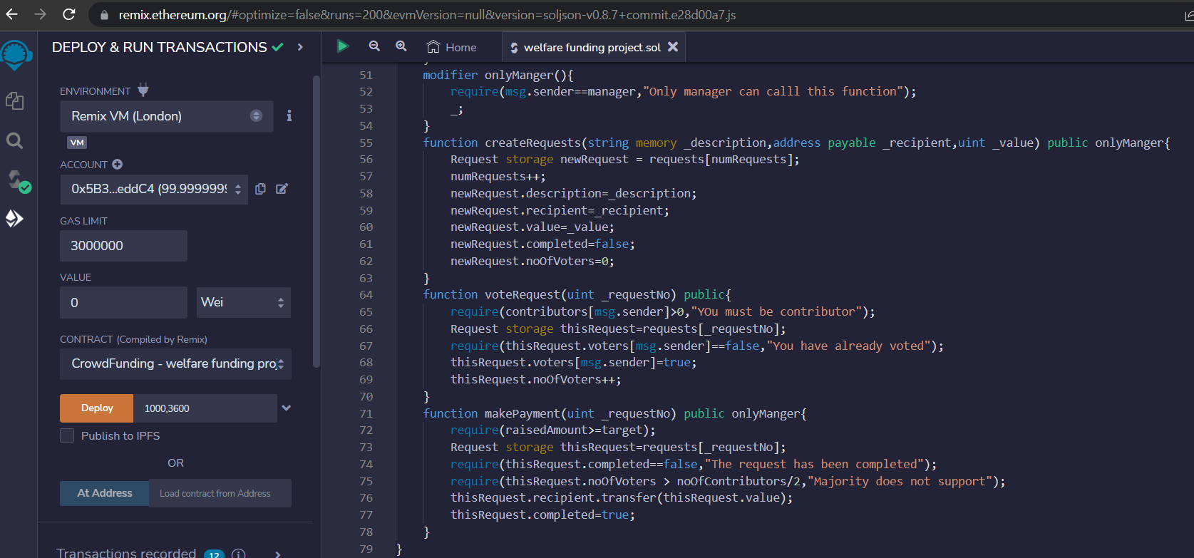

**Conclusion :-**

I have completed my project within time limit with the coordination and under the supervision of my mentor MR ABHISHEKH TIWARI(Assistant Professor)

**References:-**

## Websites:

[www.google.com](http://www.google.com)

[www.remix.org.com](http://www.remix.org.com)

[www.solidite.org](http://www.solidite.org)

[www.ethereum.com](http://www.ethereum.com)